Software Testing, Lab 1

1. Install Junit(4.12), Hamcrest(1.3) with Eclipse

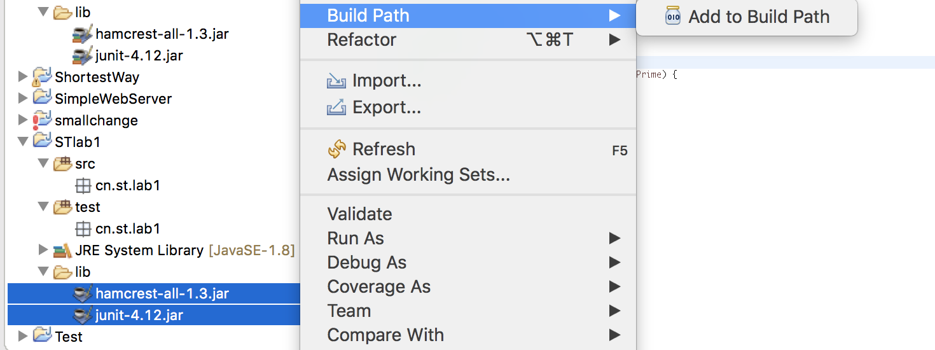

1. Install Eclemma with Eclipse

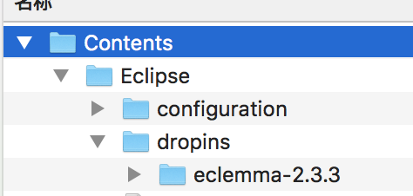

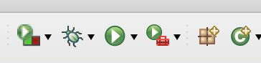

1. Write a java program for the triangle problem and test the program with Junit.

Description of triangle problem:

Function triangle takes three integers *a,b,c* which are length of triangle sides; calculates whether the triangle is equilateral, isosceles, or scalene.

Triangle.java代码：

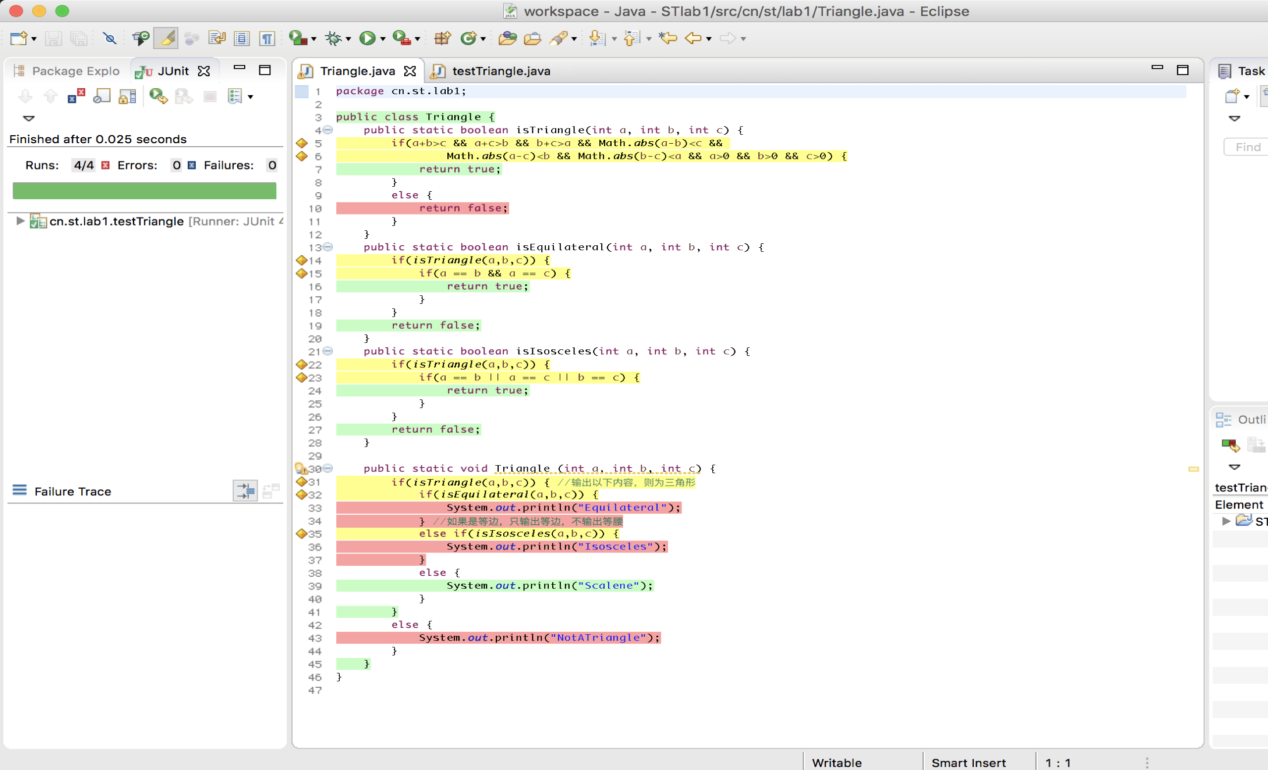

testTriangle.java代码：

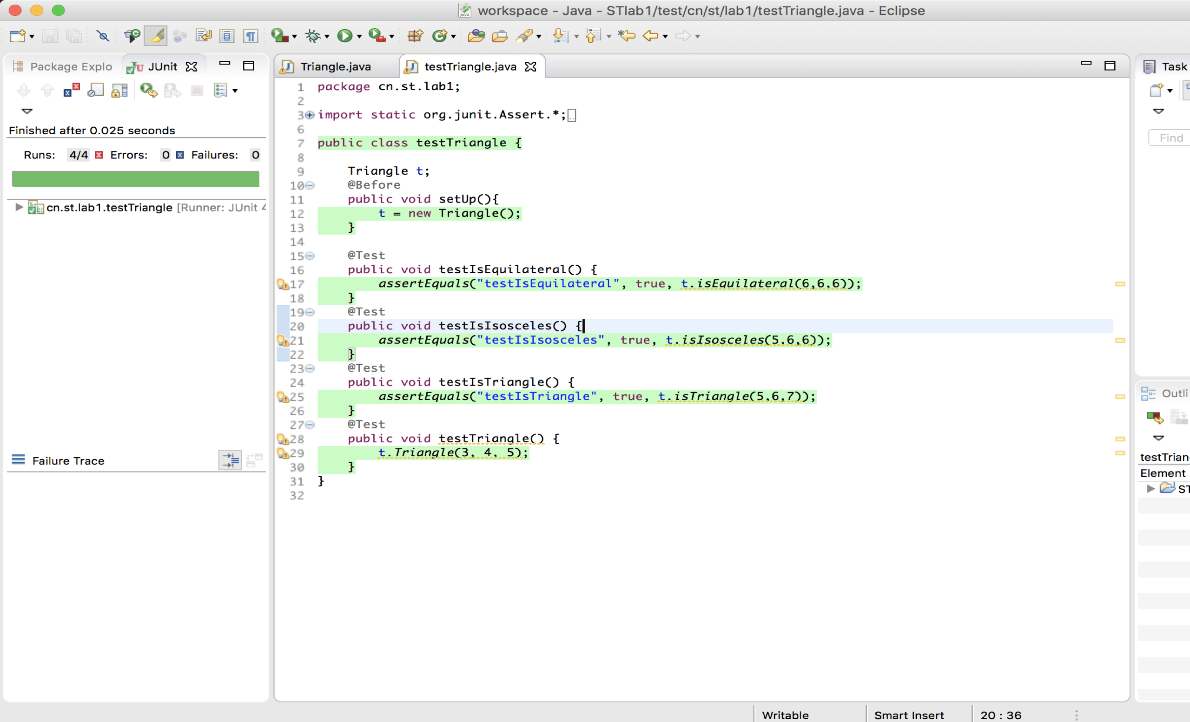

测试结果：

